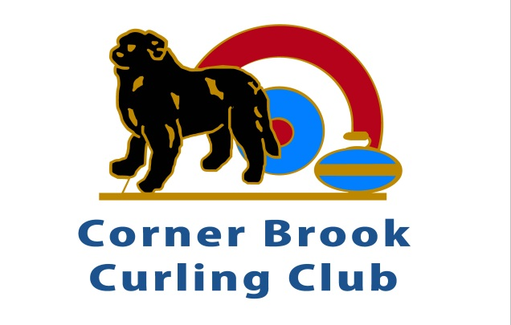
Rate Schedule for 2025-26

Corner Brook Curling Association Inc.
3 Canada Games Place
P. O. Box 116
Corner Brook, NL

Category | Total Fee (including 15% HST)
Full Membership  Unlimited curling, curl as often as you like pending availability | $525
One Night Member  Curl ONE league game per week; pay spare fee for other league games. | $395
Student Member  Registered as post secondary student with valid Student ID or High School Student; unlimited curling; curl as often as you like pending availability. | $280
Stick Curling  Curl ONE afternoon per week stick curler membership | $195
Junior Member  Ages 10-18. 1 hour per week. | $120
Little Rocks  Ages 6 to 9. Scheduled after school curling only. | $119
Spare Fee for Non Members OR One Night Member  Skip responsible to pay the spare fee for using a spare; payable before game time. | $20
50-50 Add-On  Automatically be included in 50-50 draws each week. | $42

Notes:
- 15% HST Is Included in Rates.
- Fees payable before league play commences.
- Locker rental: $40
- Evening / afternoon rental is $400 +HST for 3 hours (includes bar service).
- Daily rental on weekend is $500 +HST per day (includes bar service).
- Friday evening and Saturday or Saturday evening and Sunday is $800 +HST (includes bar service).
- School rate is $50 +HST per 50 minute session.

